Instructions to optional experiments

- Optional experiments include 2 independent tasks. The two tasks are designed for interested students. You can choose one/two tasks or none.
- Your task should be submitted as a regular research report/paper, i.e., the paper should has several sections as follows: introduction, related works, your method, experiment results and evaluation, conclusions, references, etc.
- Your report can be written in Chinese or English, but must use the provided template.
- Compress your task files (task report with ‘doc’ format, code), and your compulsory experiment files into a file：student ID_ name.zip/rar. Email the compressed file to 13451824328@163.com before Nov 30.
- Submit your report (hardcopy) to ZHU Xiangpu(朱相谱, Building D12-B, Room 404, 183 1744 8897) before Nov 30.

Note: The report should be a research report, not an experimental report.

Brief introduction to tasks

- Task1: image stitching
For images in the file folder “task1”, stitch two images from same scene (for example, img1_L and img1_R are two images from a same scene, so does img2_L and img2_R , …).
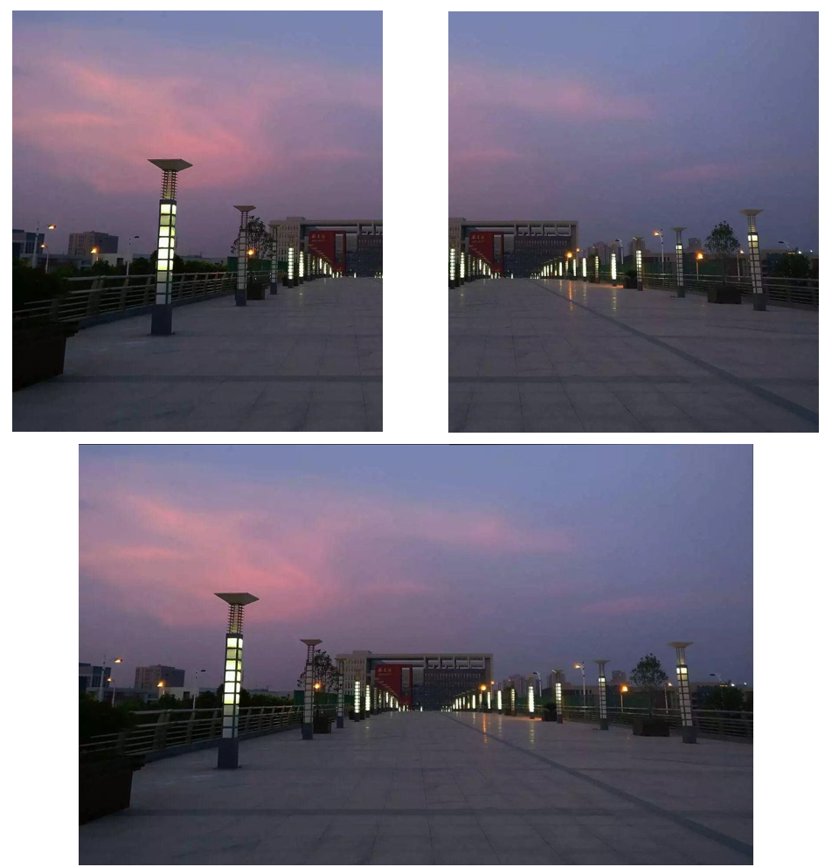

- Task2: vehicle counting and speed measurement
For video in the file folder “task2”, count the number of vehicles and measure vehicles’ speed in the tint area.

